EXERCISE 11
1. Count the number of employees who have been with BigNet for four or more years.
SELECT COUNT(*) AS 'Employees with 4 or more years' FROM employee_data
WHERE yearsofservice >= 4;
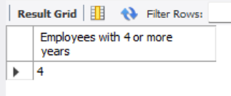

2. Count employees based on their ages.
SELECT age, COUNT(*) AS 'Number of Employees' FROM employee_data GROUP BY age;
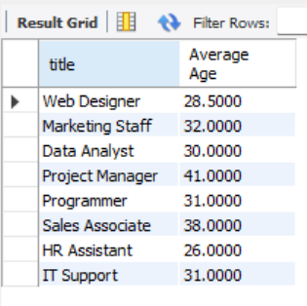

3. Modify the above so that the ages are listed in descending order.
SELECT age, COUNT(*) AS 'Number of Employees' FROM employee_data GROUP BY age ORDER BY age DESC;
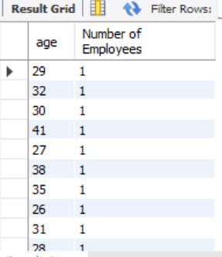

4. Find the average age of employees in different departments (titles).
SELECT title, AVG(age) AS 'Average Age' FROM employee_data GROUP BY title;
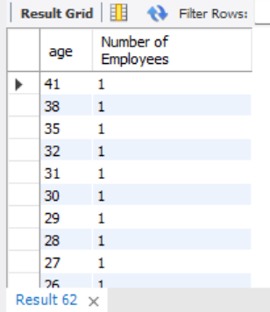

5. Change the above so that the data is displayed in descending order of average ages.
SELECT title, AVG(age) AS 'Average Age' FROM employee_data GROUP BY title ORDER BY AVG(age) DESC;
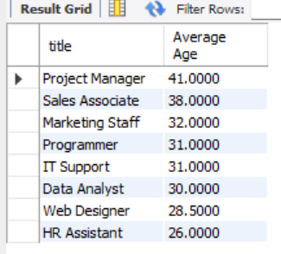

6. Find and list the percentage of perks (perks/salary * 100) for each employee, sorted in descending order.
SELECT f_name, l_name, (perks / salary * 100) AS 'Perk Percentage' FROM employee_data ORDER BY 'Perk Percentage' DESC;
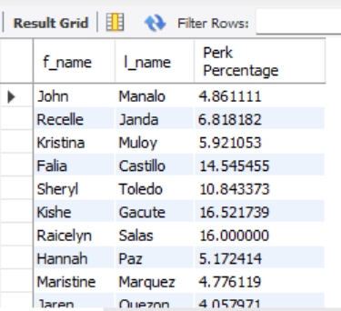

CREATE DATABASE Exercise11_ADDRESSBOOK;
USE Exercise11_ADDRESSBOOK;
CREATE TABLE employee_data (
employee_id INT AUTO_INCREMENT PRIMARY KEY,
f_name VARCHAR(100),
l_name VARCHAR(100),
title VARCHAR(100),
division VARCHAR(100),
age INT,
yearsofservice INT,
salary DECIMAL(10,2),
perks DECIMAL(10,2),
email VARCHAR(100)
);
INSERT INTO employee_data (f_name, l_name, title, division, age, yearsofservice, salary, perks, email) VALUES
('John', 'Manalo', 'Web Designer', 'IT', 29, 3, 72000, 3500, 'aaron.lopez@bignet.com'),
('Recelle', 'Janda', 'Marketing Staff', 'Marketing', 32, 4, 88000, 6000, 'bianca.santos@bignet.com'),
('Kristina', 'Muloy', 'Data Analyst', 'IT', 30, 2, 76000, 4500, 'celine.torres@bignet.com'),
('Falia', 'Castillo', 'Project Manager', 'Operations', 41, 10, 110000, 16000, 'darren.castillo@bignet.com'),
('Sheryl', 'Toledo', 'Programmer', 'IT', 27, 3, 83000, 9000, 'elaine.mendoza@bignet.com'),
('Kishe', 'Gacute', 'Sales Associate', 'Sales', 38, 7, 115000, 19000, 'francis.diaz@bignet.com'),
('Raicelyn', 'Salas', 'Programmer', 'IT', 35, 9, 125000, 20000, 'gwen.reyes@bignet.com'),
('Hannah', 'Paz', 'HR Assistant', 'HR', 26, 1, 58000, 3000, 'hannah.lim@bignet.com'),
('Maristine', 'Marquez', 'IT Support', 'IT', 31, 3, 67000, 3200, 'ivan.ramirez@bignet.com'),
('Jaren', 'Quezon', 'Web Designer', 'IT', 28, 2, 69000, 2800, 'jared.flores@bignet.com');

SELECT COUNT(*) AS 'Employees with 4 or more years' FROM employee_data WHERE yearsofservice >= 4;
SELECT age, COUNT(*) AS 'Number of Employees' FROM employee_data GROUP BY age;
SELECT age, COUNT(*) AS 'Number of Employees' FROM employee_data GROUP BY age ORDER BY age DESC;
SELECT title, AVG(age) AS 'Average Age' FROM employee_data GROUP BY title;
SELECT title, AVG(age) AS 'Average Age' FROM employee_data GROUP BY title ORDER BY AVG(age) DESC;
SELECT f_name, l_name, (perks / salary * 100) AS 'Perk Percentage' FROM employee_data ORDER BY 'Perk Percentage' DESC;

